Emotion based music recommendation- Project #2

* The purposed model will extract user’s facial expression and features to determine the current mood of the user.
* The emotion are recognized with efficient and accurate algorithm , that would generate a playlist based on current emotion state and behavior of user.

The objective of this project is as follows:

* Emotion Detection Accuracy
* Real-time Responsiveness
* Therapeutic Applications
* User Engagement Enhancement
* Personalized Music Recommendations

**Please note** - Requirment documentation contains details on user stories, test cases, and design mockups to each requirement to provide more clarity and context for the development team.

**Test Cases for Unit Testing (Email and Password verification)**

|  |  |  |  |  |  |
| --- | --- | --- | --- | --- | --- |
| **Test Case ID** | **Test Description** | **Input Data** | **Expected Result** | **Actual Result** | **Remarks** |
| 1 | Register new user with valid email and other details | Name: Nirjala Shrestha  Email: snirjala01@gmail.com  Password: ****  RePassword: **** | Registered successfully | Registered successfully | Pass |
| 2 | Login using valid email and other details | Email: snirjala01@gmail.com  Password: **** | Login successfully | Login successfully | Pass |
| 3 | Login using invalid email and other details | Email: riya@gmail.com  Password: ***** | Login Unsuccessful to home screen. | Login failed. Please check your email and password | Pass |
| 4 | Register new user with invalid email and other details |  |  |  |  |

Email Validity

|  |  |  |  |  |
| --- | --- | --- | --- | --- |
| **Test case** | **Test scenario** | **Test Data** | **Expected Outcome** | **Result** |
| 1 | Check empty value | null | Show error | pass |
| 2 | Check result without including ‘@’ character | 1234 | Show error | pass |
| 3 | Check result with @ character | kabir@gmail.com | Valid | Pass |

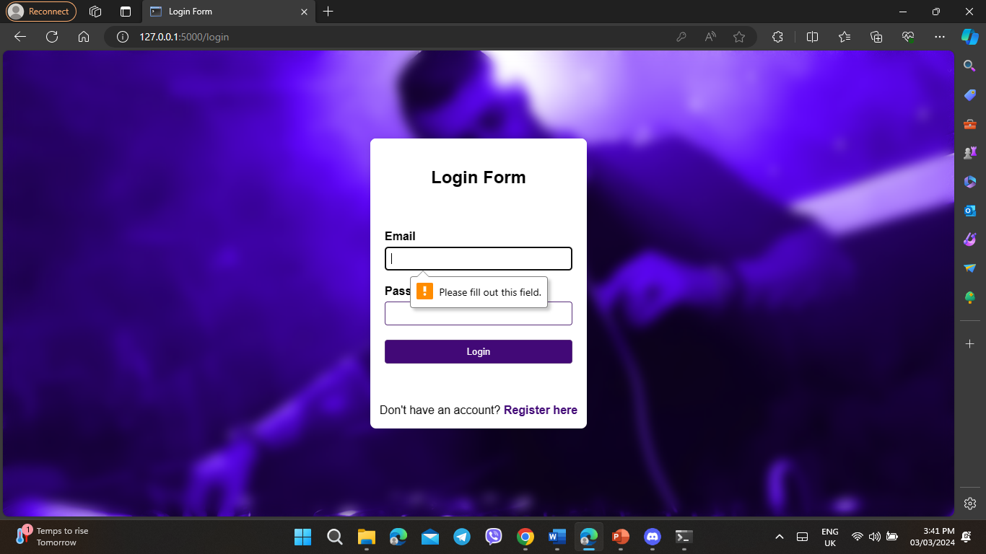 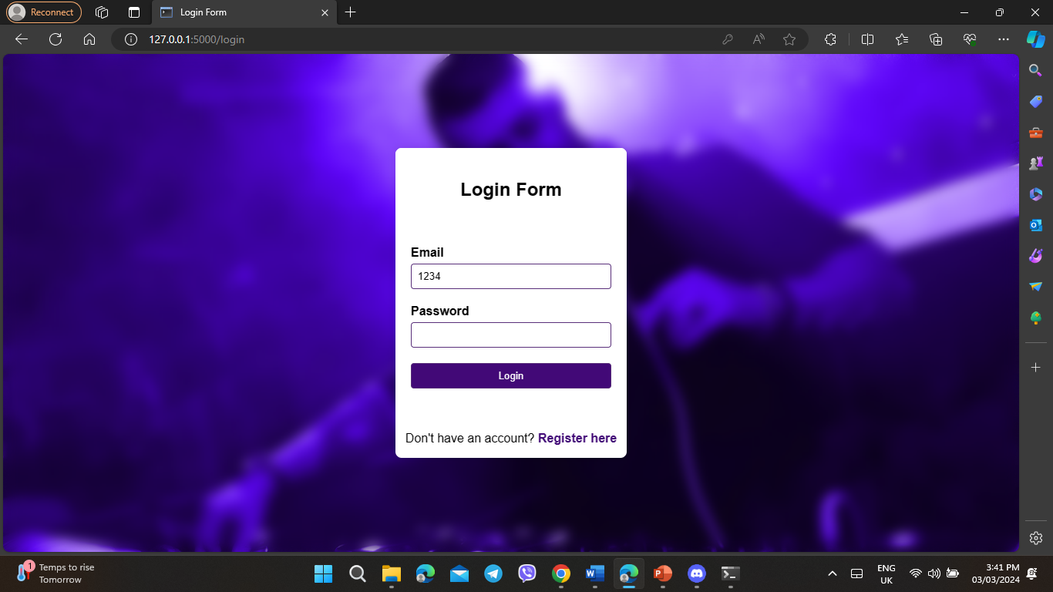

Test cases for System Testing

|  |  |  |  |  |  |
| --- | --- | --- | --- | --- | --- |
| **Test**  **Case**  **ID** | **Test**  **Description** | **Input Data** | **Expected**  **Result** | **Actual**  **Result** | **Remarks** |
| 1 | Testing camera permission request functionality. | Select ok for the permission | Detect the user’s face | User’s Face is captured correctly | Pass |
| 2 | Verify that the system accurately detects and classifies facial emotions | Facial expressions representing emotions (e.g., sad, happy, angry, calm, energetic) | system correctly identifies the input facial expressions into specified emotions. | system accurately detects and classifies facial emotions | Facial emotion recognition is functioning correctly |
| 3 | Confirm that the system generates appropriate music recommendations based on emotions | Detected emotions (e.g., sad, happy, angry, calm, energetic, neutral) | system recommends music playlists that correspond to the detected emotions | system provides accurate music recommendations aligned with the detected emotions. | pass |
| 4 | Testing music playback functionality. | Click on the "Play" button for the recommended playlist. | Music from the recommended playlist starts playing. | Music from the recommended playlist starts playing. | Pass |
| 5 | Testing system response to low light inputs. | Present user’s face in low light condition | Recommend song based on detected emotion | Doesn’t recognize user’s face | Fail |
| 6 | Validate the logout system | Click on Logout button | system logs out the user from their current session | system successfully logs out the user, ending the session | Pass |

### Login

**User Stories**

As a new user, I want to be able to create a new account and login to the platform.

As an existing user, I want to be able to easily access my account by entering my login credentials.

**Design Mockups**

Login page design mockup

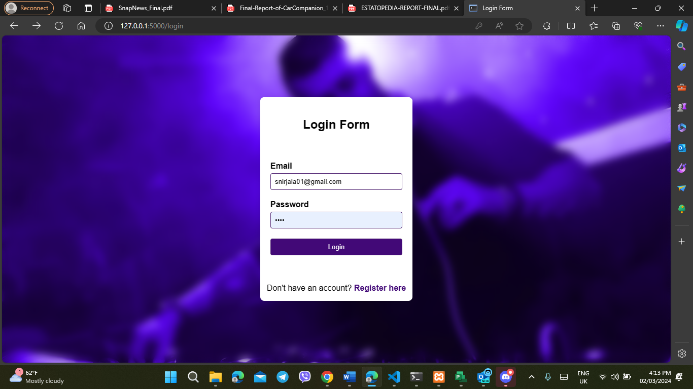

### Registration

As a new user, I want to be able to easily create a new account and register for the platform.

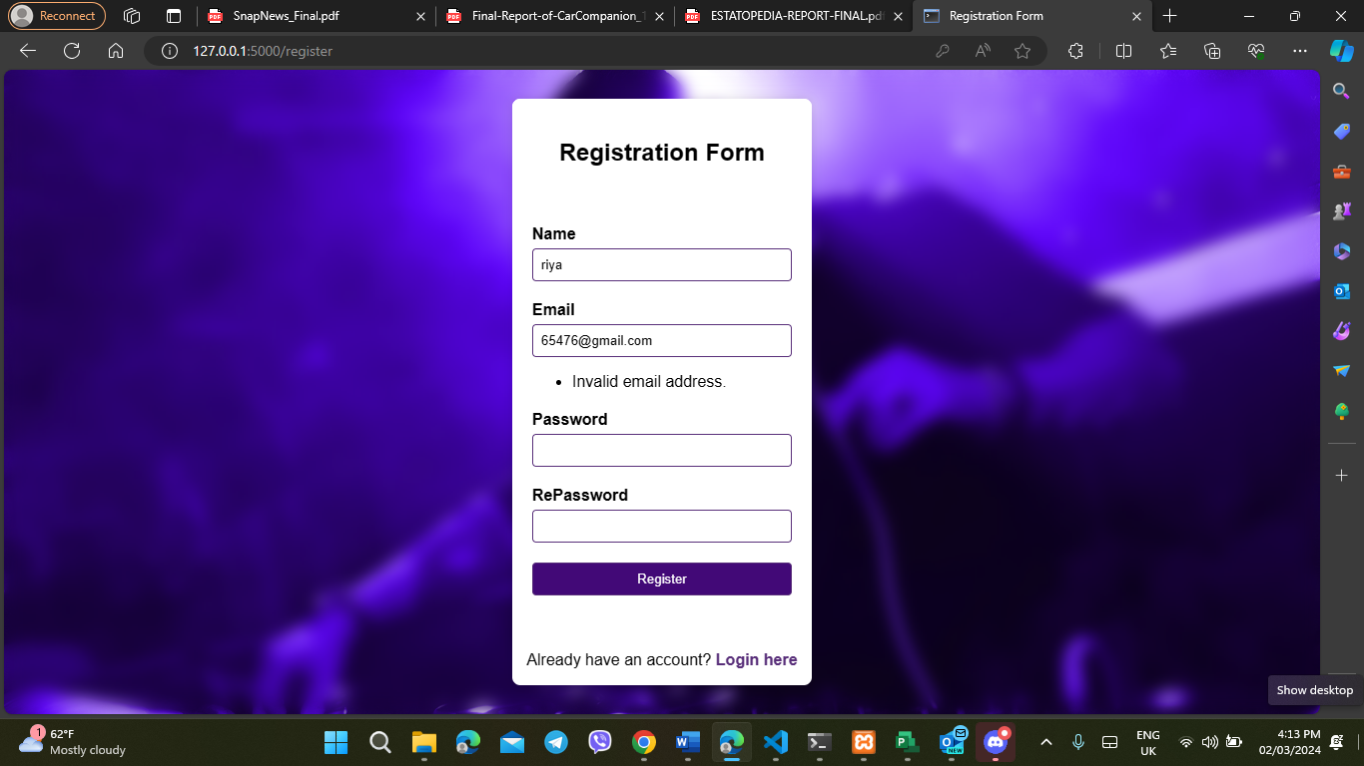

### Camera Permission

Ask for Camera permission

Design Mockups

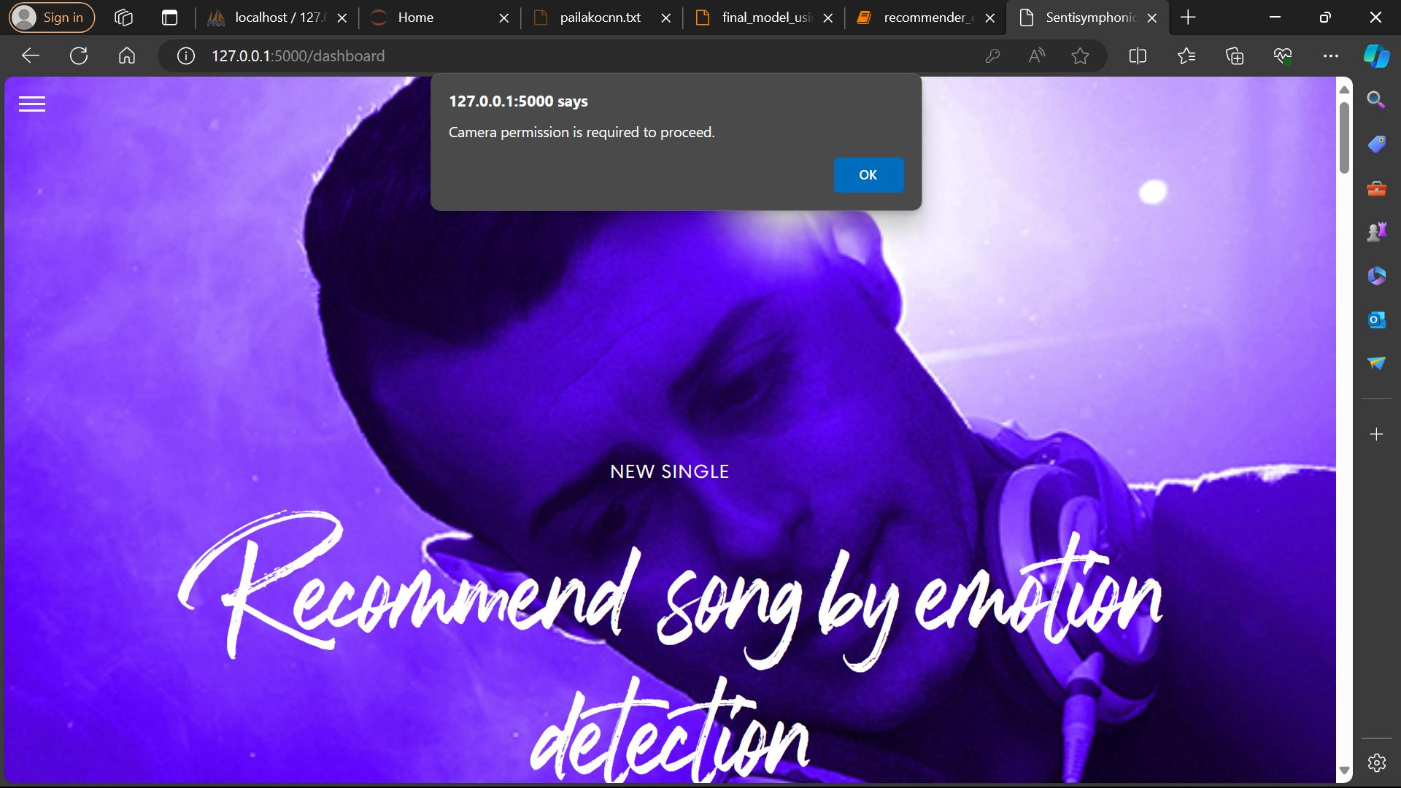

### Identify the emotion

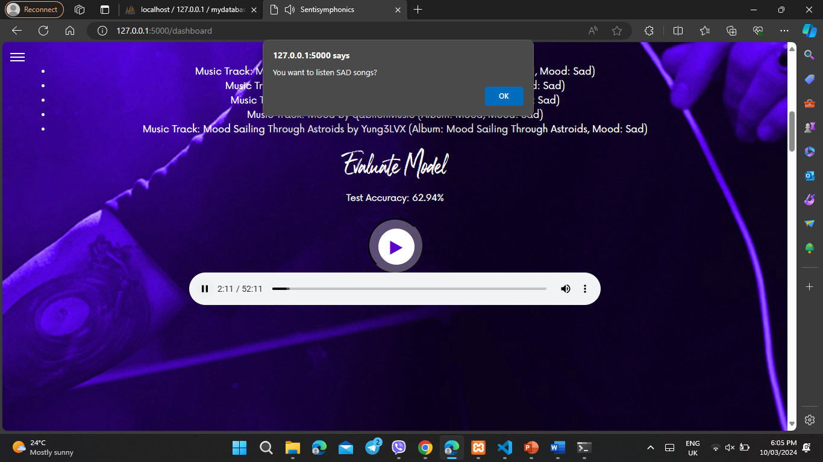

### Playing a corresponding song

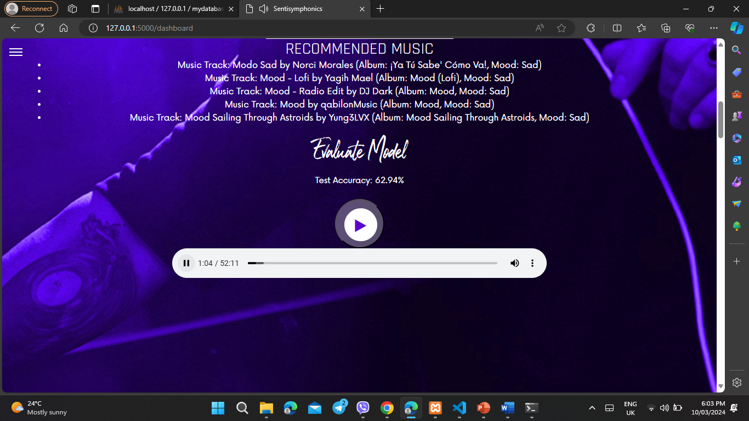

**Change in accuracy with changing emotion**

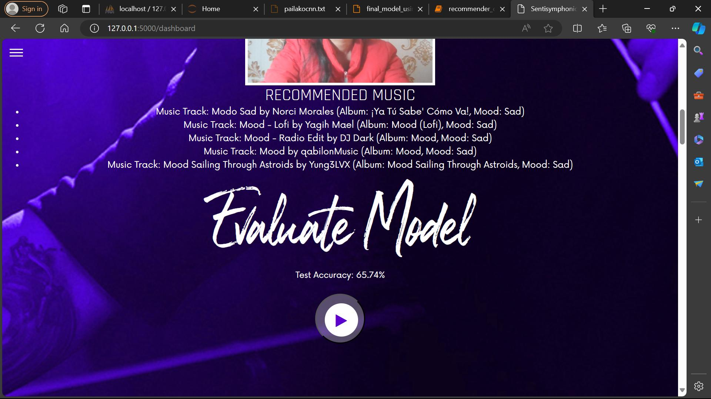

**Login form after user logout**

